Types of testing Covered:
- Smoke Testing
- Sanity Testing
- Regression Testing
- Load Testing
- Negative and Positive scenario testing
- Switch OFF and ON Coverage
Bugs Inquired during Testing
- Bug 1248296 : Item Class Wrong
- Bug 1249738: Decimal value below .4 issue
- Bug 1249090: Decimal value below .5 issue
- Bug 1244558: Mismatch of Itemclass with Ashley Net, and Sql reflects in Microservices
- Bug 1248212: No values populating with excel attached values
- Bug 1248273: Status Shows 2 but Results Null
Queries Raised
- 1
Testing Sample Screenshots of data
POST API URL: https://aazeus-fnprwb01.ashleyfurniture.com/AdjustmentAPI/Adjustment/Orders
INPUT:
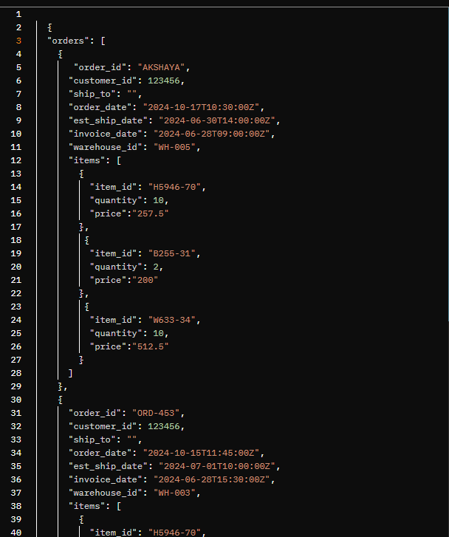
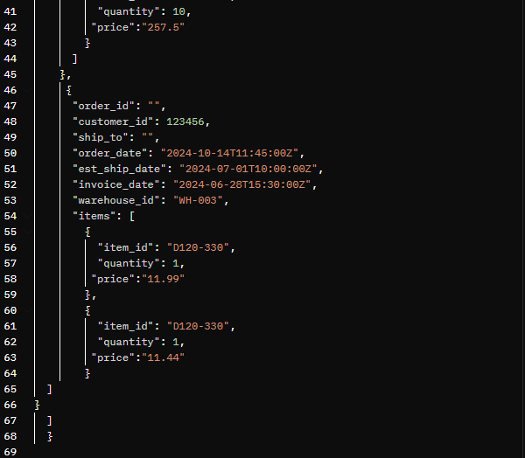

Output:
- Switch OFF
- 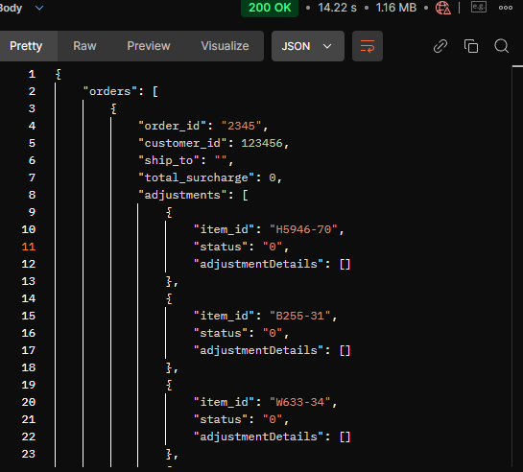
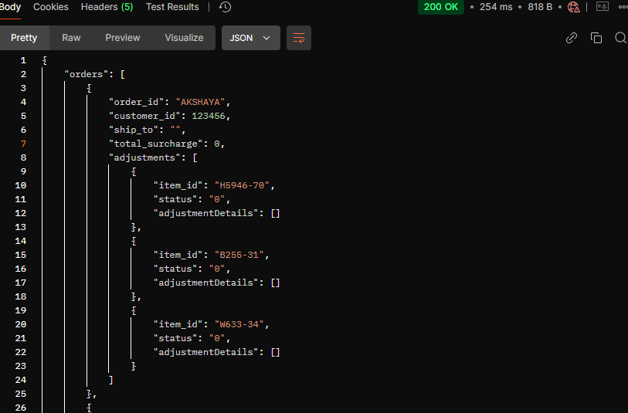
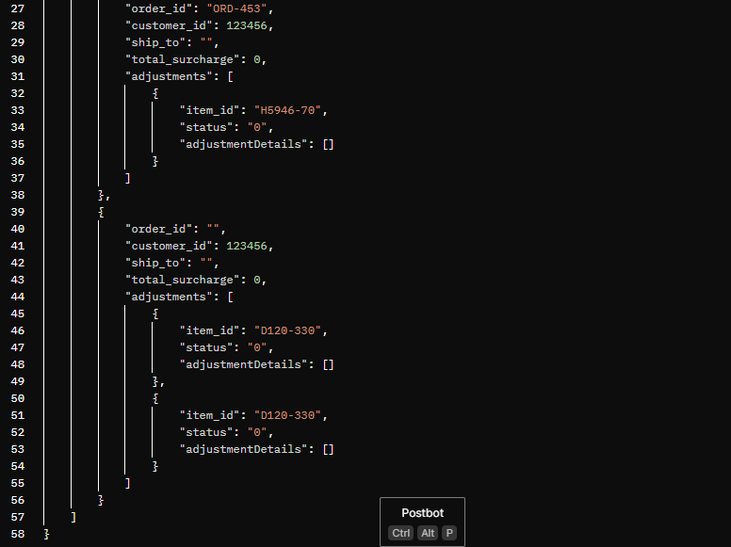

- Switch ON
Sample :
{
"orders": [
{
"order_id": "D493959",
"customer_id": 131100,
"ship_to": "02",
"order_date": "10/3/2024",
"est_ship_date": "",
"invoice_date": "",
"warehouse_id": "ECR",
"items": [
{
"item_id": "W633-34",
"quantity": 40,
"price": 144.79
},
{
"item_id": "6400412",
"quantity": 12,
"price": "549.99"
},
{
"item_id": "6420208",
"quantity": 7,
"price": "429.99"
},
{
"item_id": "6420213",
"quantity": 15,
"price": "689.50"
},
{
"item_id": "6420215",
"quantity": 4,
"price": "299.99"
},
{
"item_id": "6420218",
"quantity": 18,
"price": "799.99"
},
{
"item_id": "6420308",
"quantity": 6,
"price": "459.99"
},
{
"item_id": "6420313",
"quantity": 9,
"price": "529.99"
},
{
"item_id": "6420315",
"quantity": 11,
"price": "649.99"
},
{
"item_id": "6420318",
"quantity": 3,
"price": "279.99"
},
{
"item_id": "6440316",
"quantity": 16,
"price": "749.99"
},
{
"item_id": "6440317",
"quantity": 8,
"price": "489.99"
},
{
"item_id": "6440334",
"quantity": 13,
"price": "599.99"
},
{
"item_id": "6440346",
"quantity": 5,
"price": "349.99"
},
{
"item_id": "6440355",
"quantity": 14,
"price": "679.99"
},
{
"item_id": "6440356",
"quantity": 7,
"price": "449.99"
},
{
"item_id": "6440377",
"quantity": 19,
"price": "849.99"
},
{
"item_id": "6440399",
"quantity": 10,
"price": "559.99"
},
{
"item_id": "6460535",
"quantity": 6,
"price": "399.99"
},
{
"item_id": "6460538",
"quantity": 12,
"price": "629.99"
},
{
"item_id": "6460735",
"quantity": 8,
"price": "479.99"
},
{
"item_id": "6460738",
"quantity": 15,
"price": "729.99"
},
{
"item_id": "7500814",
"quantity": 4,
"price": "319.99"
},
{
"item_id": "7500816",
"quantity": 17,
"price": "779.99"
},
{
"item_id": "7500817",
"quantity": 9,
"price": "519.99"
},
{
"item_id": "7500818",
"quantity": 11,
"price": "589.99"
},
{
"item_id": "7500820",
"quantity": 6,
"price": "419.99"
},
{
"item_id": "7500825",
"quantity": 13,
"price": "649.99"
},
{
"item_id": "7500835",
"quantity": 8,
"price": "489.99"
},
{
"item_id": "7500836",
"quantity": 16,
"price": "759.99"
},
{
"item_id": "7500838",
"quantity": 5,
"price": "359.99"
},
{
"item_id": "7500855",
"quantity": 14,
"price": "699.99"
},
{
"item_id": "7500856",
"quantity": 7,
"price": "449.99"
},
{
"item_id": "7500866",
"quantity": 18,
"price": "829.99"
},
{
"item_id": "7500867",
"quantity": 10,
"price": "569.99"
},
{
"item_id": "7500883",
"quantity": 6,
"price": "399.99"
},
{
"item_id": "7500910",
"quantity": 12,
"price": "639.99"
},
{
"item_id": "7500916",
"quantity": 8,
"price": "479.99"
},
{
"item_id": "7500917",
"quantity": 15,
"price": "719.99"
},
{
"item_id": "7500918",
"quantity": 4,
"price": "329.99"
},
{
"item_id": "7500925",
"quantity": 17,
"price": "789.99"
},
{
"item_id": "7500936",
"quantity": 9,
"price": "529.99"
},
{
"item_id": "7500966",
"quantity": 11,
"price": "599.99"
},
{
"item_id": "7500967",
"quantity": 6,
"price": "429.99"
},
{
"item_id": "7500983",
"quantity": 13,
"price": "659.99"
},
{
"item_id": "7540708",
"quantity": 8,
"price": "499.99"
},
{
"item_id": "7540713",
"quantity": 16,
"price": "769.99"
},
{
"item_id": "7540713C",
"quantity": 5,
"price": "369.99"
},
{
"item_id": "7540715",
"quantity": 14,
"price": "709.99"
},
{
"item_id": "7540715C",
"quantity": 7,
"price": "459.99"
},
{
"item_id": "7540718",
"quantity": 19,
"price": "839.99"
},
{
"item_id": "7540718C",
"quantity": 8,
"price": "489.99"
},
{
"item_id": "7540737",
"quantity": 13,
"price": "629.99"
},
{
"item_id": "7540777",
"quantity": 6,
"price": "349.99"
},
{
"item_id": "7570325",
"quantity": 15,
"price": "749.99"
},
{
"item_id": "7570425",
"quantity": 4,
"price": "299.99"
},
{
"item_id": "7580235",
"quantity": 11,
"price": "599.99"
},
{
"item_id": "7580238",
"quantity": 7,
"price": "459.99"
},
{
"item_id": "7590906",
"quantity": 16,
"price": "779.99"
},
{
"item_id": "7590906C",
"quantity": 9,
"price": "529.99"
},
{
"item_id": "7591006",
"quantity": 12,
"price": "649.99"
},
{
"item_id": "7591006C",
"quantity": 5,
"price": "329.99"
},
{
"item_id": "7610535",
"quantity": 14,
"price": "699.99"
},
{
"item_id": "7610538",
"quantity": 8,
"price": "479.99"
},
{
"item_id": "7620425",
"quantity": 17,
"price": "829.99"
},
{
"item_id": "7620489",
"quantity": 10,
"price": "559.99"
},
{
"item_id": "7540718C",
"quantity": 8,
"price": "489.99"
},
{
"item_id": "7540737",
"quantity": 13,
"price": "629.99"
},
{
"item_id": "7540777",
"quantity": 6,
"price": "349.99"
},
{
"item_id": "7570325",
"quantity": 15,
"price": "749.99"
},
{
"item_id": "7570425",
"quantity": 4,
"price": "299.99"
},
{
"item_id": "7580235",
"quantity": 11,
"price": "599.99"
},
{
"item_id": "7580238",
"quantity": 7,
"price": "459.99"
},
{
"item_id": "7590906",
"quantity": 16,
"price": "779.99"
},
{
"item_id": "7590906C",
"quantity": 9,
"price": "529.99"
},
{
"item_id": "7591006",
"quantity": 12,
"price": "649.99"
},
{
"item_id": "7591006C",
"quantity": 5,
"price": "329.99"
},
{
"item_id": "7610535",
"quantity": 14,
"price": "699.99"
},
{
"item_id": "7610538",
"quantity": 8,
"price": "479.99"
},
{
"item_id": "7620425",
"quantity": 17,
"price": "829.99"
},
{
"item_id": "7620489",
"quantity": 10,
"price": "559.99"
},
{
"item_id": "7620494",
"quantity": 3,
"price": "279.99"
},
{
"item_id": "7630406",
"quantity": 18,
"price": "859.99"
},
{
"item_id": "7650425",
"quantity": 7,
"price": "449.99"
},
{
"item_id": "7650425C",
"quantity": 13,
"price": "679.99"
},
{
"item_id": "7650487",
"quantity": 6,
"price": "389.99"
},
{
"item_id": "7540718C",
"quantity": 8,
"price": "489.99"
},
{
"item_id": "7540737",
"quantity": 13,
"price": "629.99"
},
{
"item_id": "7540777",
"quantity": 6,
"price": "349.99"
},
{
"item_id": "7570325",
"quantity": 15,
"price": "749.99"
},
{
"item_id": "7570425",
"quantity": 4,
"price": "299.99"
},
{
"item_id": "7580235",
"quantity": 11,
"price": "599.99"
},
{
"item_id": "7580238",
"quantity": 7,
"price": "459.99"
},
{
"item_id": "7590906",
"quantity": 16,
"price": "779.99"
},
{
"item_id": "7590906C",
"quantity": 9,
"price": "529.99"
},
{
"item_id": "7591006",
"quantity": 12,
"price": "649.99"
},
{
"item_id": "7591006C",
"quantity": 5,
"price": "329.99"
},
{
"item_id": "7610535",
"quantity": 14,
"price": "699.99"
},
{
"item_id": "7610538",
"quantity": 8,
"price": "479.99"
},
{
"item_id": "7620425",
"quantity": 17,
"price": "829.99"
},
{
"item_id": "7620489",
"quantity": 10,
"price": "559.99"
},
{
"item_id": "7620494",
"quantity": 3,
"price": "279.99"
},
{
"item_id": "7630406",
"quantity": 18,
"price": "859.99"
},
{
"item_id": "7650425",
"quantity": 7,
"price": "449.99"
},
{
"item_id": "7650425C",
"quantity": 13,
"price": "679.99"
},
{
"item_id": "7650487",
"quantity": 6,
"price": "389.99"
}
]
}

]
}

Output:
{
"orders": [
{
"order_id": "D493959",
"customer_id": 131100,
"ship_to": "02",
"total_surcharge": 1233.00,
"adjustments": [
{
"item_id": "W633-34",
"status": "2",
"adjustmentDetails": [
{
"credit_code": "ISC",
"adjustment_name": "ISC IMPORT SURCHARGE",
"adjustment_amount": 40.00,
"invoice_level": "1",
"taxable": "N",
"commissionable": "N",
"quantity": 40,
"calculation_value": 5.0000,
"calculation_type": "PERCENT",
"applied_level": "ITEMCLASS",
"applied_level_value": "ZECD",
"charge": true,
"price": 144.79
},
{
"credit_code": "SSC",
"adjustment_name": "SSC IMPORT SURCHARGE SALES",
"adjustment_amount": 40.00,
"invoice_level": "1",
"taxable": "N",
"commissionable": "N",
"quantity": 40,
"calculation_value": 6.0000,
"calculation_type": "PERCENT",
"applied_level": "ITEMCLASS",
"applied_level_value": "ZECD",
"charge": true,
"price": 144.79
}
]
},
{
"item_id": "6400412",
"status": "2",
"adjustmentDetails": [
{
"credit_code": "ISC",
"adjustment_name": "ISC IMPORT SURCHARGE",
"adjustment_amount": 36.00,
"invoice_level": "1",
"taxable": "N",
"commissionable": "N",
"quantity": 12,
"calculation_value": 5.0000,
"calculation_type": "PERCENT",
"applied_level": "ITEMCLASS",
"applied_level_value": "ZVUS",
"charge": true,
"price": 549.99
}
]
},
{
"item_id": "6420208",
"status": "2",
"adjustmentDetails": [
{
"credit_code": "ISC",
"adjustment_name": "ISC IMPORT SURCHARGE",
"adjustment_amount": 28.00,
"invoice_level": "1",
"taxable": "N",
"commissionable": "N",
"quantity": 7,
"calculation_value": 5.0000,
"calculation_type": "PERCENT",
"applied_level": "ITEMCLASS",
"applied_level_value": "ZVUS",
"charge": true,
"price": 429.99
}
]
},
{
"item_id": "6420213",
"status": "2",
"adjustmentDetails": [
{
"credit_code": "ISC",
"adjustment_name": "ISC IMPORT SURCHARGE",
"adjustment_amount": 45.00,
"invoice_level": "1",
"taxable": "N",
"commissionable": "N",
"quantity": 15,
"calculation_value": 5.0000,
"calculation_type": "PERCENT",
"applied_level": "ITEMCLASS",
"applied_level_value": "ZVUS",
"charge": true,
"price": 689.50
}
]
},
{
"item_id": "6420215",
"status": "2",
"adjustmentDetails": [
{
"credit_code": "ISC",
"adjustment_name": "ISC IMPORT SURCHARGE",
"adjustment_amount": 16.00,
"invoice_level": "1",
"taxable": "N",
"commissionable": "N",
"quantity": 4,
"calculation_value": 5.0000,
"calculation_type": "PERCENT",
"applied_level": "ITEMCLASS",
"applied_level_value": "ZVUS",
"charge": true,
"price": 299.99
}
]
},
{
"item_id": "6420218",
"status": "2",
"adjustmentDetails": [
{
"credit_code": "ISC",
"adjustment_name": "ISC IMPORT SURCHARGE",
"adjustment_amount": 54.00,
"invoice_level": "1",
"taxable": "N",
"commissionable": "N",
"quantity": 18,
"calculation_value": 5.0000,
"calculation_type": "PERCENT",
"applied_level": "ITEMCLASS",
"applied_level_value": "ZVUS",
"charge": true,
"price": 799.99
}
]
},
{
"item_id": "6420308",
"status": "2",
"adjustmentDetails": [
{
"credit_code": "ISC",
"adjustment_name": "ISC IMPORT SURCHARGE",
"adjustment_amount": 24.00,
"invoice_level": "1",
"taxable": "N",
"commissionable": "N",
"quantity": 6,
"calculation_value": 5.0000,
"calculation_type": "PERCENT",
"applied_level": "ITEMCLASS",
"applied_level_value": "ZVUS",
"charge": true,
"price": 459.99
}
]
},
{
"item_id": "6420313",
"status": "2",
"adjustmentDetails": [
{
"credit_code": "ISC",
"adjustment_name": "ISC IMPORT SURCHARGE",
"adjustment_amount": 27.00,
"invoice_level": "1",
"taxable": "N",
"commissionable": "N",
"quantity": 9,
"calculation_value": 5.0000,
"calculation_type": "PERCENT",
"applied_level": "ITEMCLASS",
"applied_level_value": "ZVUS",
"charge": true,
"price": 529.99
}
]
},
{
"item_id": "6420315",
"status": "2",
"adjustmentDetails": [
{
"credit_code": "ISC",
"adjustment_name": "ISC IMPORT SURCHARGE",
"adjustment_amount": 33.00,
"invoice_level": "1",
"taxable": "N",
"commissionable": "N",
"quantity": 11,
"calculation_value": 5.0000,
"calculation_type": "PERCENT",
"applied_level": "ITEMCLASS",
"applied_level_value": "ZVUS",
"charge": true,
"price": 649.99
}
]
},
{
"item_id": "6420318",
"status": "2",
"adjustmentDetails": [
{
"credit_code": "ISC",
"adjustment_name": "ISC IMPORT SURCHARGE",
"adjustment_amount": 15.00,
"invoice_level": "1",
"taxable": "N",
"commissionable": "N",
"quantity": 3,
"calculation_value": 5.0000,
"calculation_type": "PERCENT",
"applied_level": "ITEMCLASS",
"applied_level_value": "ZVUS",
"charge": true,
"price": 279.99
}
]
},
{
"item_id": "6440316",
"status": "1",
"adjustmentDetails": []
},
{
"item_id": "6440317",
"status": "1",
"adjustmentDetails": []
},
{
"item_id": "6440334",
"status": "1",
"adjustmentDetails": []
},
{
"item_id": "6440346",
"status": "1",
"adjustmentDetails": []
},
{
"item_id": "6440355",
"status": "1",
"adjustmentDetails": []
},
{
"item_id": "6440356",
"status": "1",
"adjustmentDetails": []
},
{
"item_id": "6440377",
"status": "1",
"adjustmentDetails": []
},
{
"item_id": "6440399",
"status": "1",
"adjustmentDetails": []
},
{
"item_id": "6460535",
"status": "1",
"adjustmentDetails": []
},
{
"item_id": "6460538",
"status": "1",
"adjustmentDetails": []
},
{
"item_id": "6460735",
"status": "1",
"adjustmentDetails": []
},
{
"item_id": "6460738",
"status": "1",
"adjustmentDetails": []
},
{
"item_id": "7500814",
"status": "1",
"adjustmentDetails": []
},
{
"item_id": "7500816",
"status": "1",
"adjustmentDetails": []
},
{
"item_id": "7500817",
"status": "1",
"adjustmentDetails": []
},
{
"item_id": "7500818",
"status": "1",
"adjustmentDetails": []
},
{
"item_id": "7500820",
"status": "1",
"adjustmentDetails": []
},
{
"item_id": "7500825",
"status": "1",
"adjustmentDetails": []
},
{
"item_id": "7500835",
"status": "1",
"adjustmentDetails": []
},
{
"item_id": "7500836",
"status": "1",
"adjustmentDetails": []
},
{
"item_id": "7500838",
"status": "1",
"adjustmentDetails": []
},
{
"item_id": "7500855",
"status": "1",
"adjustmentDetails": []
},
{
"item_id": "7500856",
"status": "1",
"adjustmentDetails": []
},
{
"item_id": "7500866",
"status": "1",
"adjustmentDetails": []
},
{
"item_id": "7500867",
"status": "1",
"adjustmentDetails": []
},
{
"item_id": "7500883",
"status": "1",
"adjustmentDetails": []
},
{
"item_id": "7500910",
"status": "1",
"adjustmentDetails": []
},
{
"item_id": "7500916",
"status": "1",
"adjustmentDetails": []
},
{
"item_id": "7500917",
"status": "1",
"adjustmentDetails": []
},
{
"item_id": "7500918",
"status": "1",
"adjustmentDetails": []
},
{
"item_id": "7500925",
"status": "1",
"adjustmentDetails": []
},
{
"item_id": "7500936",
"status": "1",
"adjustmentDetails": []
},
{
"item_id": "7500966",
"status": "1",
"adjustmentDetails": []
},
{
"item_id": "7500967",
"status": "1",
"adjustmentDetails": []
},
{
"item_id": "7500983",
"status": "1",
"adjustmentDetails": []
},
{
"item_id": "7540708",
"status": "2",
"adjustmentDetails": [
{
"credit_code": "ISC",
"adjustment_name": "ISC IMPORT SURCHARGE",
"adjustment_amount": 32.00,
"invoice_level": "1",
"taxable": "N",
"commissionable": "N",
"quantity": 8,
"calculation_value": 5.0000,
"calculation_type": "PERCENT",
"applied_level": "ITEMCLASS",
"applied_level_value": "ZVUS",
"charge": true,
"price": 499.99
}
]
},
{
"item_id": "7540713",
"status": "2",
"adjustmentDetails": [
{
"credit_code": "ISC",
"adjustment_name": "ISC IMPORT SURCHARGE",
"adjustment_amount": 48.00,
"invoice_level": "1",
"taxable": "N",
"commissionable": "N",
"quantity": 16,
"calculation_value": 5.0000,
"calculation_type": "PERCENT",
"applied_level": "ITEMCLASS",
"applied_level_value": "ZVUS",
"charge": true,
"price": 769.99
}
]
},
{
"item_id": "7540713C",
"status": "2",
"adjustmentDetails": [
{
"credit_code": "ISC",
"adjustment_name": "ISC IMPORT SURCHARGE",
"adjustment_amount": 20.00,
"invoice_level": "1",
"taxable": "N",
"commissionable": "N",
"quantity": 5,
"calculation_value": 5.0000,
"calculation_type": "PERCENT",
"applied_level": "ITEMCLASS",
"applied_level_value": "ZVUS",
"charge": true,
"price": 369.99
}
]
},
{
"item_id": "7540715",
"status": "2",
"adjustmentDetails": [
{
"credit_code": "ISC",
"adjustment_name": "ISC IMPORT SURCHARGE",
"adjustment_amount": 42.00,
"invoice_level": "1",
"taxable": "N",
"commissionable": "N",
"quantity": 14,
"calculation_value": 5.0000,
"calculation_type": "PERCENT",
"applied_level": "ITEMCLASS",
"applied_level_value": "ZVUS",
"charge": true,
"price": 709.99
}
]
},
{
"item_id": "7540715C",
"status": "2",
"adjustmentDetails": [
{
"credit_code": "ISC",
"adjustment_name": "ISC IMPORT SURCHARGE",
"adjustment_amount": 28.00,
"invoice_level": "1",
"taxable": "N",
"commissionable": "N",
"quantity": 7,
"calculation_value": 5.0000,
"calculation_type": "PERCENT",
"applied_level": "ITEMCLASS",
"applied_level_value": "ZVUS",
"charge": true,
"price": 459.99
}
]
},
{
"item_id": "7540718",
"status": "2",
"adjustmentDetails": [
{
"credit_code": "ISC",
"adjustment_name": "ISC IMPORT SURCHARGE",
"adjustment_amount": 57.00,
"invoice_level": "1",
"taxable": "N",
"commissionable": "N",
"quantity": 19,
"calculation_value": 5.0000,
"calculation_type": "PERCENT",
"applied_level": "ITEMCLASS",
"applied_level_value": "ZVUS",
"charge": true,
"price": 839.99
}
]
},
{
"item_id": "7540718C",
"status": "2",
"adjustmentDetails": [
{
"credit_code": "ISC",
"adjustment_name": "ISC IMPORT SURCHARGE",
"adjustment_amount": 32.00,
"invoice_level": "1",
"taxable": "N",
"commissionable": "N",
"quantity": 8,
"calculation_value": 5.0000,
"calculation_type": "PERCENT",
"applied_level": "ITEMCLASS",
"applied_level_value": "ZVUS",
"charge": true,
"price": 489.99
}
]
},
{
"item_id": "7540737",
"status": "2",
"adjustmentDetails": [
{
"credit_code": "ISC",
"adjustment_name": "ISC IMPORT SURCHARGE",
"adjustment_amount": 39.00,
"invoice_level": "1",
"taxable": "N",
"commissionable": "N",
"quantity": 13,
"calculation_value": 5.0000,
"calculation_type": "PERCENT",
"applied_level": "ITEMCLASS",
"applied_level_value": "ZVUS",
"charge": true,
"price": 629.99
}
]
},
{
"item_id": "7540777",
"status": "2",
"adjustmentDetails": [
{
"credit_code": "ISC",
"adjustment_name": "ISC IMPORT SURCHARGE",
"adjustment_amount": 18.00,
"invoice_level": "1",
"taxable": "N",
"commissionable": "N",
"quantity": 6,
"calculation_value": 5.0000,
"calculation_type": "PERCENT",
"applied_level": "ITEMCLASS",
"applied_level_value": "ZVUS",
"charge": true,
"price": 349.99
}
]
},
{
"item_id": "7570325",
"status": "2",
"adjustmentDetails": [
{
"credit_code": "ISC",
"adjustment_name": "ISC IMPORT SURCHARGE",
"adjustment_amount": 45.00,
"invoice_level": "1",
"taxable": "N",
"commissionable": "N",
"quantity": 15,
"calculation_value": 5.0000,
"calculation_type": "PERCENT",
"applied_level": "ITEMCLASS",
"applied_level_value": "ZVUS",
"charge": true,
"price": 749.99
}
]
},
{
"item_id": "7570425",
"status": "2",
"adjustmentDetails": [
{
"credit_code": "ISC",
"adjustment_name": "ISC IMPORT SURCHARGE",
"adjustment_amount": 16.00,
"invoice_level": "1",
"taxable": "N",
"commissionable": "N",
"quantity": 4,
"calculation_value": 5.0000,
"calculation_type": "PERCENT",
"applied_level": "ITEMCLASS",
"applied_level_value": "ZVUS",
"charge": true,
"price": 299.99
}
]
},
{
"item_id": "7580235",
"status": "1",
"adjustmentDetails": []
},
{
"item_id": "7580238",
"status": "1",
"adjustmentDetails": []
},
{
"item_id": "7590906",
"status": "1",
"adjustmentDetails": []
},
{
"item_id": "7590906C",
"status": "1",
"adjustmentDetails": []
},
{
"item_id": "7591006",
"status": "1",
"adjustmentDetails": []
},
{
"item_id": "7591006C",
"status": "1",
"adjustmentDetails": []
},
{
"item_id": "7610535",
"status": "2",
"adjustmentDetails": [
{
"credit_code": "ISC",
"adjustment_name": "ISC IMPORT SURCHARGE",
"adjustment_amount": 42.00,
"invoice_level": "1",
"taxable": "N",
"commissionable": "N",
"quantity": 14,
"calculation_value": 5.0000,
"calculation_type": "PERCENT",
"applied_level": "ITEMCLASS",
"applied_level_value": "ZBUC",
"charge": true,
"price": 699.99
}
]
},
{
"item_id": "7610538",
"status": "2",
"adjustmentDetails": [
{
"credit_code": "ISC",
"adjustment_name": "ISC IMPORT SURCHARGE",
"adjustment_amount": 24.00,
"invoice_level": "1",
"taxable": "N",
"commissionable": "N",
"quantity": 8,
"calculation_value": 5.0000,
"calculation_type": "PERCENT",
"applied_level": "ITEMCLASS",
"applied_level_value": "ZBUC",
"charge": true,
"price": 479.99
}
]
},
{
"item_id": "7620425",
"status": "1",
"adjustmentDetails": []
},
{
"item_id": "7620489",
"status": "1",
"adjustmentDetails": []
},
{
"item_id": "7540718C",
"status": "2",
"adjustmentDetails": [
{
"credit_code": "ISC",
"adjustment_name": "ISC IMPORT SURCHARGE",
"adjustment_amount": 32.00,
"invoice_level": "1",
"taxable": "N",
"commissionable": "N",
"quantity": 8,
"calculation_value": 5.0000,
"calculation_type": "PERCENT",
"applied_level": "ITEMCLASS",
"applied_level_value": "ZVUS",
"charge": true,
"price": 489.99
}
]
},
{
"item_id": "7540737",
"status": "2",
"adjustmentDetails": [
{
"credit_code": "ISC",
"adjustment_name": "ISC IMPORT SURCHARGE",
"adjustment_amount": 39.00,
"invoice_level": "1",
"taxable": "N",
"commissionable": "N",
"quantity": 13,
"calculation_value": 5.0000,
"calculation_type": "PERCENT",
"applied_level": "ITEMCLASS",
"applied_level_value": "ZVUS",
"charge": true,
"price": 629.99
}
]
},
{
"item_id": "7540777",
"status": "2",
"adjustmentDetails": [
{
"credit_code": "ISC",
"adjustment_name": "ISC IMPORT SURCHARGE",
"adjustment_amount": 18.00,
"invoice_level": "1",
"taxable": "N",
"commissionable": "N",
"quantity": 6,
"calculation_value": 5.0000,
"calculation_type": "PERCENT",
"applied_level": "ITEMCLASS",
"applied_level_value": "ZVUS",
"charge": true,
"price": 349.99
}
]
},
{
"item_id": "7570325",
"status": "2",
"adjustmentDetails": [
{
"credit_code": "ISC",
"adjustment_name": "ISC IMPORT SURCHARGE",
"adjustment_amount": 45.00,
"invoice_level": "1",
"taxable": "N",
"commissionable": "N",
"quantity": 15,
"calculation_value": 5.0000,
"calculation_type": "PERCENT",
"applied_level": "ITEMCLASS",
"applied_level_value": "ZVUS",
"charge": true,
"price": 749.99
}
]
},
{
"item_id": "7570425",
"status": "2",
"adjustmentDetails": [
{
"credit_code": "ISC",
"adjustment_name": "ISC IMPORT SURCHARGE",
"adjustment_amount": 16.00,
"invoice_level": "1",
"taxable": "N",
"commissionable": "N",
"quantity": 4,
"calculation_value": 5.0000,
"calculation_type": "PERCENT",
"applied_level": "ITEMCLASS",
"applied_level_value": "ZVUS",
"charge": true,
"price": 299.99
}
]
},
{
"item_id": "7580235",
"status": "1",
"adjustmentDetails": []
},
{
"item_id": "7580238",
"status": "1",
"adjustmentDetails": []
},
{
"item_id": "7590906",
"status": "1",
"adjustmentDetails": []
},
{
"item_id": "7590906C",
"status": "1",
"adjustmentDetails": []
},
{
"item_id": "7591006",
"status": "1",
"adjustmentDetails": []
},
{
"item_id": "7591006C",
"status": "1",
"adjustmentDetails": []
},
{
"item_id": "7610535",
"status": "2",
"adjustmentDetails": [
{
"credit_code": "ISC",
"adjustment_name": "ISC IMPORT SURCHARGE",
"adjustment_amount": 42.00,
"invoice_level": "1",
"taxable": "N",
"commissionable": "N",
"quantity": 14,
"calculation_value": 5.0000,
"calculation_type": "PERCENT",
"applied_level": "ITEMCLASS",
"applied_level_value": "ZBUC",
"charge": true,
"price": 699.99
}
]
},
{
"item_id": "7610538",
"status": "2",
"adjustmentDetails": [
{
"credit_code": "ISC",
"adjustment_name": "ISC IMPORT SURCHARGE",
"adjustment_amount": 24.00,
"invoice_level": "1",
"taxable": "N",
"commissionable": "N",
"quantity": 8,
"calculation_value": 5.0000,
"calculation_type": "PERCENT",
"applied_level": "ITEMCLASS",
"applied_level_value": "ZBUC",
"charge": true,
"price": 479.99
}
]
},
{
"item_id": "7620425",
"status": "1",
"adjustmentDetails": []
},
{
"item_id": "7620489",
"status": "1",
"adjustmentDetails": []
},
{
"item_id": "7620494",
"status": "1",
"adjustmentDetails": []
},
{
"item_id": "7630406",
"status": "1",
"adjustmentDetails": []
},
{
"item_id": "7650425",
"status": "1",
"adjustmentDetails": []
},
{
"item_id": "7650425C",
"status": "1",
"adjustmentDetails": []
},
{
"item_id": "7650487",
"status": "1",
"adjustmentDetails": []
},
{
"item_id": "7540718C",
"status": "2",
"adjustmentDetails": [
{
"credit_code": "ISC",
"adjustment_name": "ISC IMPORT SURCHARGE",
"adjustment_amount": 32.00,
"invoice_level": "1",
"taxable": "N",
"commissionable": "N",
"quantity": 8,
"calculation_value": 5.0000,
"calculation_type": "PERCENT",
"applied_level": "ITEMCLASS",
"applied_level_value": "ZVUS",
"charge": true,
"price": 489.99
}
]
},
{
"item_id": "7540737",
"status": "2",
"adjustmentDetails": [
{
"credit_code": "ISC",
"adjustment_name": "ISC IMPORT SURCHARGE",
"adjustment_amount": 39.00,
"invoice_level": "1",
"taxable": "N",
"commissionable": "N",
"quantity": 13,
"calculation_value": 5.0000,
"calculation_type": "PERCENT",
"applied_level": "ITEMCLASS",
"applied_level_value": "ZVUS",
"charge": true,
"price": 629.99
}
]
},
{
"item_id": "7540777",
"status": "2",
"adjustmentDetails": [
{
"credit_code": "ISC",
"adjustment_name": "ISC IMPORT SURCHARGE",
"adjustment_amount": 18.00,
"invoice_level": "1",
"taxable": "N",
"commissionable": "N",
"quantity": 6,
"calculation_value": 5.0000,
"calculation_type": "PERCENT",
"applied_level": "ITEMCLASS",
"applied_level_value": "ZVUS",
"charge": true,
"price": 349.99
}
]
},
{
"item_id": "7570325",
"status": "2",
"adjustmentDetails": [
{
"credit_code": "ISC",
"adjustment_name": "ISC IMPORT SURCHARGE",
"adjustment_amount": 45.00,
"invoice_level": "1",
"taxable": "N",
"commissionable": "N",
"quantity": 15,
"calculation_value": 5.0000,
"calculation_type": "PERCENT",
"applied_level": "ITEMCLASS",
"applied_level_value": "ZVUS",
"charge": true,
"price": 749.99
}
]
},
{
"item_id": "7570425",
"status": "2",
"adjustmentDetails": [
{
"credit_code": "ISC",
"adjustment_name": "ISC IMPORT SURCHARGE",
"adjustment_amount": 16.00,
"invoice_level": "1",
"taxable": "N",
"commissionable": "N",
"quantity": 4,
"calculation_value": 5.0000,
"calculation_type": "PERCENT",
"applied_level": "ITEMCLASS",
"applied_level_value": "ZVUS",
"charge": true,
"price": 299.99
}
]
},
{
"item_id": "7580235",
"status": "1",
"adjustmentDetails": []
},
{
"item_id": "7580238",
"status": "1",
"adjustmentDetails": []
},
{
"item_id": "7590906",
"status": "1",
"adjustmentDetails": []
},
{
"item_id": "7590906C",
"status": "1",
"adjustmentDetails": []
},
{
"item_id": "7591006",
"status": "1",
"adjustmentDetails": []
},
{
"item_id": "7591006C",
"status": "1",
"adjustmentDetails": []
},
{
"item_id": "7610535",
"status": "2",
"adjustmentDetails": [
{
"credit_code": "ISC",
"adjustment_name": "ISC IMPORT SURCHARGE",
"adjustment_amount": 42.00,
"invoice_level": "1",
"taxable": "N",
"commissionable": "N",
"quantity": 14,
"calculation_value": 5.0000,
"calculation_type": "PERCENT",
"applied_level": "ITEMCLASS",
"applied_level_value": "ZBUC",
"charge": true,
"price": 699.99
}
]
},
{
"item_id": "7610538",
"status": "2",
"adjustmentDetails": [
{
"credit_code": "ISC",
"adjustment_name": "ISC IMPORT SURCHARGE",
"adjustment_amount": 24.00,
"invoice_level": "1",
"taxable": "N",
"commissionable": "N",
"quantity": 8,
"calculation_value": 5.0000,
"calculation_type": "PERCENT",
"applied_level": "ITEMCLASS",
"applied_level_value": "ZBUC",
"charge": true,
"price": 479.99
}
]
},
{
"item_id": "7620425",
"status": "1",
"adjustmentDetails": []
},
{
"item_id": "7620489",
"status": "1",
"adjustmentDetails": []
},
{
"item_id": "7620494",
"status": "1",
"adjustmentDetails": []
},
{
"item_id": "7630406",
"status": "1",
"adjustmentDetails": []
},
{
"item_id": "7650425",
"status": "1",
"adjustmentDetails": []
},
{
"item_id": "7650425C",
"status": "1",
"adjustmentDetails": []
},
{
"item_id": "7650487",
"status": "1",
"adjustmentDetails": []
}
]
}
]
}

Some more addon information:
Microservices records as far Observed
- 1-10 Records within: 245MS
- Within 100 Records within: 2.04 Seconds
- 100-800+ Records: 4.06S - 17.9 Seconds
- 800-5000+ Records: 1.04 Minutes
- 10k - 20K Records: 5.34 Minutes

This Includes all within same order item call, different item different order calls

